**Perkins Somerset Oldtown ENOUGH Advisory Committee Meeting**

**Time: 9:30 AM – 11:30 AM**  
**Location: City Springs Elementary Middle School, 100 S Caroline Street**

**Meeting Result:** Partners will be oriented to current PSO community data and contributing community factors, recognizing key insights identified so far. All participants will develop a shared understanding of the collaborative roles and responsibilities of advisory organizations in supporting community priorities.

| **Time** | **Agenda** |
| --- | --- |
| **9:30-9:50** | **Welcome, Check-In**  **Facilitator:** Brooke Epstein, Assistant Project Manager  **Result:** Participants are checked in, settled, and ready to work. |
| **9:50—10:50** | **Partnering Around the Work: Data Walk, Factor Analysis, Solution Finding Discussion**  **Facilitator:** Tyronda Minter, VP Educational Initiatives and Brooke Epstein, Assistant Project Manager    **Result:** Participants are informed on the PSO community and goals of ENOUGH. |
| **10:20-11:00** | **Data Review: Baselining Together PSO needs, opportunities, and assets**  **Facilitator:** Tyronda Minter, VP Educational Initiatives and Brooke Epstein, Assistant Project Manager  **Result:** Participants are informed on data points that impact the PSO community. |
| **10:50-11:20** | **Next Steps: How do we get there as a group? Affirming your organization's contributions and Housing in the PSO Footprint**  **Facilitator:** Subira Brown, Senior Project Manager  **Result:** Participants have shared alignment on expectations and housing in PSO. |
| **11:20- 11:30** | **Closing, Action Commitments & Next Steps**  **Facilitator:** Tyronda Minter, VP Educational Initiatives  **Result:** Participants are informed of the next steps. |

**June E2S Meeting**

**Wednesday, June 04, 2025**

**9:30am – 11:30pm**

**Location:  City Springs Elementary Middle School**

**100 South Caroline Street Baltimore, MD 21231**

***MEETING OVERVIEW***

* **Partners will be oriented to current PSO community data and contributing community factors, recognizing key insights identified so far.**
* **All participants will develop a shared understanding of the collaborative roles and responsibilities of advisory organizations in supporting community priorities.**
* **Overview on Governor Wes Moore Enough Grant**

**SESSION NOTES**

**Welcome and Check In**

|  |  |
| --- | --- |
| **WHO** | **ORGANIZATION** |
| **Darryl** | **MOED** |
| **Sade** | **The Family Tree** |
| **Kendra** | **BCPSS** |
| **Rachel** | **Port Discovery** |
| **Meg** | **Living Classrooms** |
| **Joe** | **Buddies Inc.** |
| **Ronald** | **RJY Chick Webb** |
| **Thelma (on behalf of Ronald)** | **RJY Chick Webb** |
| **Arnold** | **Baltimore Police Department** |
| **Joseph** | **Abell Foundation** |
| **Veronica** | **Living Classroom** |
| **Lisa** | **Little Italy Neighborhood Association** |
| **Ahmad** | **Y of Central Maryland** |
| **Seema** | **SST** |
| **Sarah** | **Improving Education** |
| **Sabriya** | **JHU (School of Public Health)** |
| **Cynthia** | **HABC** |
| **Tisiki** | **Governor’s Office For Children** |
| **Tiffany** | **Family League of Baltimore** |
| **Travis** | **Living Classrooms** |

**Synthesis of Check In**

***Facilitation by Subira Brown (senior project manager) & Brooke Epstein* (assistant project manager)**

**Q1. What Does Work In Alignment With Community Mean To You?**

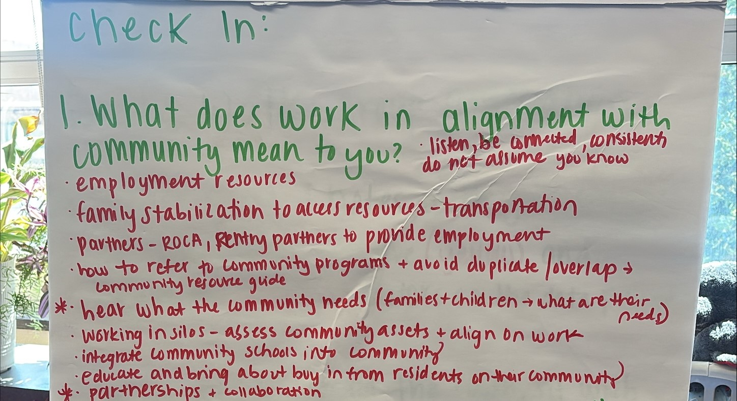

**Q2. What can your organization contribute to the PSO Efforts To Strengthen Our Partnership & Shared Responsibility**

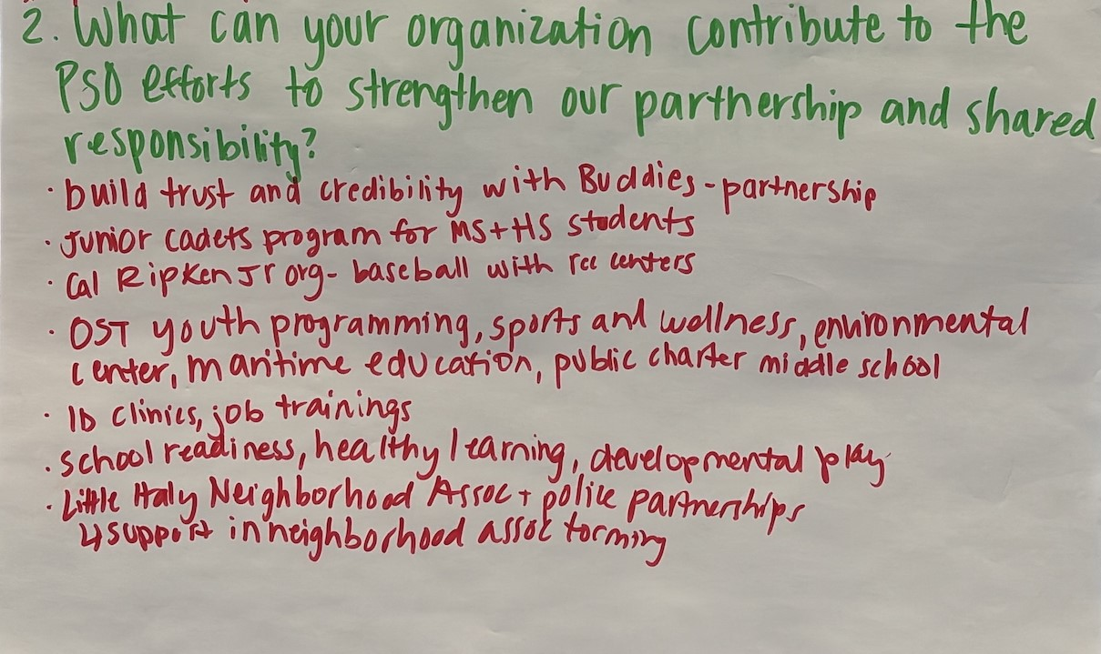

**Partnering Around the Work: Data Walk, Factor Analysis, Solution Finding Discussion**

***Facilitators: Tyronda Minter, VP Educational Initiatives and Brooke Epstein, Assistant Project Manager***

*Participants are informed on the PSO community and goals of ENOUGH.*

|  |  |
| --- | --- |
|  |  |

Several critical issues emerged from the data walk, underscoring deep community challenges. A striking 60% of single adults are living below the poverty line, and the area is designated as medically underserved, indicating limited access to essential healthcare. Education and youth development are also areas of concern: kindergarten readiness is below 50%, math proficiency scores are alarmingly low, and there’s been an increase in the number of youths not in school or employed. While college enrollment in 2022 reached 50%, which is a positive note, earlier educational gaps suggest ongoing struggles that may impact long-term success.

|  |  |
| --- | --- |
| **Factor Analysis** | * Differences in neighborhoods contribute to the crime rate. * Elevation of resident voices is not a high percentage * Generational poverty * Section 3 has been failing its residents * Struggles within hiring, careers, jobs, etc. * 64% of children from elementary to middle school unenrolled in school, absenteeism, etc. * Decreased proficiency & literacy level for children and parents |
| **Solution Finding Discussion** | * Allow residents to have input and even work on upcoming projects within the community and even an opportunity to earn residuals. * Incorporate match-play into summer programing to increase math scores * Incorporating Financial literacy in curriculum to build a connection to the real world * Financial literacy programs within organizations and schools for children and adults * Apply pressure on officials to turn around the language regarding commitment on section 3 hiring * Building a pipeline and utilizing community resources to address hiring/jobs gaps for residents. * Coordinate and align partnerships within communities and organizations * Interventions on education and allowing parents to increase their literacy and family mentorship (Thread Organization) |

**Data Review Baselining Together PSO needs, opportunities, and assets**

1. ***What is needed in the PSO footprint?***

* **Educational equity**
* **Resident voice & advocacy**
* **Workforce development**
* **Health access**
* **Partnership coordination**

1. ***What opportunities exist within the PSO footprint?***

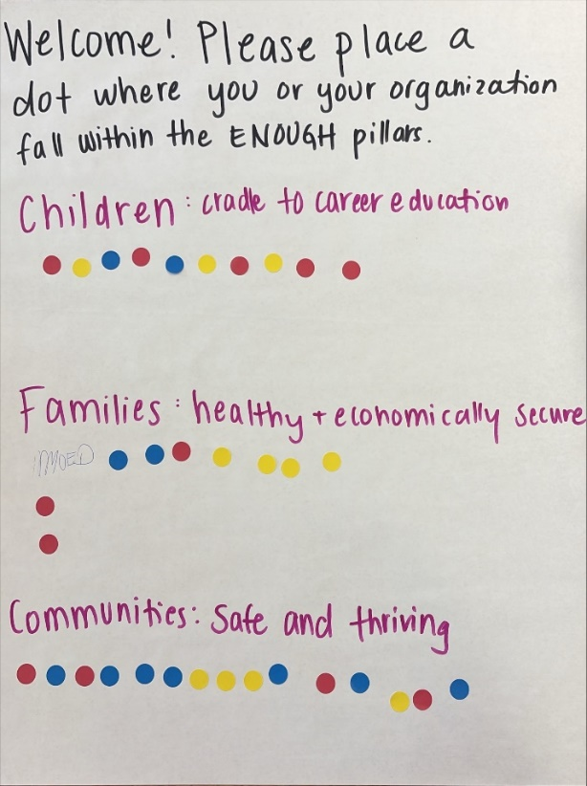

1. ***Do any assets exist within this footprint, if so what are they?***

* Diverse and committed partner organizations
* Preliminary data and community analysis
* Emerging program ideas and educational initiatives
* Resident and organizational will to collaborate
* Anchor institutions and spaces

**Recentering Continued**

***How do we get there as a group? (Affirming your organization's contributions and Housing in the PSO Footprint)***

***Result:*** We aim to collaborate with existing community networks to better understand and reflect the voices of residents. By uplifting these perspectives—through surveys, voice recordings, and other inclusive feedback tools—we can ensure that community input directly shapes more impactful and equitable outcomes.

**Additional Discussion**

How can we collaborate to design a comprehensive survey for residents? What insights are most important to gather from families and service providers, and what five key topics should we prioritize in the survey?

**Closing: Action commitments and next steps**

Commit to creating meaningful opportunities for families and collaborate as partners to uplift and strengthen the PSO community.

**Homework/Prep for Next Session**

During June and July, please engage with residents across the PSO footprint—including employers, youth, adults, elders, and partners—to help elevate their voices. Then, in our virtual August meeting, we’ll come together to discuss and refine our strategy based on the insights gathered.