**Enough Kick Off: PSO Community Meeting Notes**

Tuesday, April 29th ,2025

9:30am – 11:30am

Location: Perkins Square

226 South Caroline Street Baltimore, MD 21231

***Check In: Introduce yourself with your name and organization. In your view, what are our top community assets?***

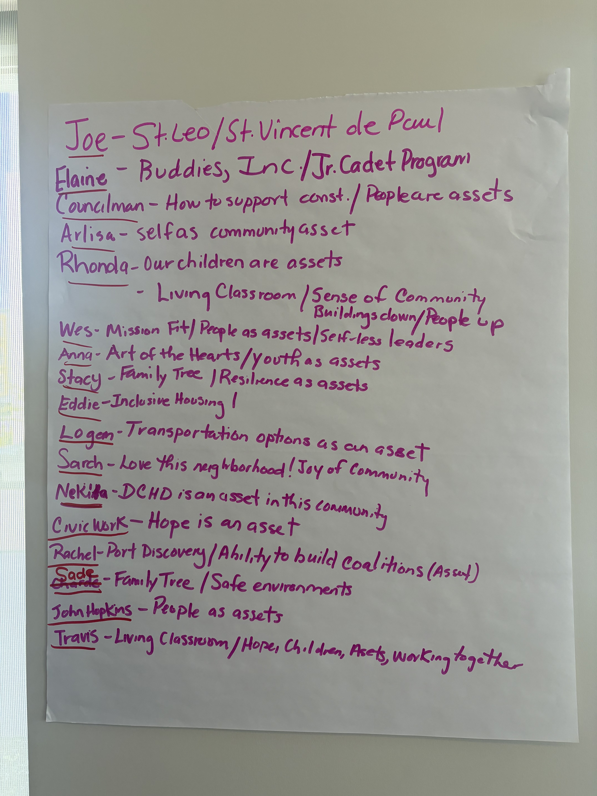

***Who is Urban Strategies INC. & How do they contribute to the community?***

|  |  |
| --- | --- |
| **Mission & Work in PSO Community** | Participants understand USI’s long-standing presence and investment in PSO |
| **Historical Review of USI** | Operating in Baltimore since 2012, current PSO team active since 2018. |
| **USI Mission** | Ensure all children and families are stable and thriving. |
| **Investment** | $227 million secured to reinvest into the PSO community. |
| **Focus Area** | Targeting Perkins Somerset Oldtown (PSO). |

***What is the ENOUGH Grant?***

*Facilitated By: Subira Brown (Senior Project Manager)*

* A federal initiative to eradicate childhood poverty.
* It is set to address 5 pillars: Economic Mobility, Education, Health, Housing Stabilization, Policy & Influence, and Workforce Development.
* What we aim to do with this grant - Support PSO through partnerships, shared data, and aligned strategies.

***Exploration: “What's in your community?”***

*Facilitated By: Subira Brown (SPM) & Brooke Epstein (APM)*

|  |  |
| --- | --- |
| **Community Asset Category** | **Count of Mentions** |
| Health & Wellness | ***7*** |
| Education & Youth Development | ***13*** |
| Housing & Homeownership | ***7*** |
| Community Services & Support | ***10*** |
| Economic Development & Jobs | ***9*** |
| Transportation & Accessibility | ***3*** |
| Public Safety & Justice | ***4*** |

|  |  |
| --- | --- |
| **Community Services & Support**   * 24/7 Parent Helpline * Free child care + transportation * In-home daycare providers * Childcare provider support * Village of Love & Resistance * UA House * First Apostolic Faith Church * Church/faith-based charity | **Economic Development & Employment**   * YouthWorks * Hospitality industry * Free workforce development & education * Power House * Public markets * Corner stores * Farmers market * Monument Street shops * Barber shops |
| **Education & Youth Development**   * Crossroads School * College & career readiness (K–12) * Dunbar High School * Hopkins School of Medicine & Nursing * Libraries * Museums * Parenting classes * Baltimore Police Cadet Program * Junior cadet events/scholarships * City Springs Elementary * Outreach, community service * Weekend mass (some youth/education overlap) | **Health & Wellness**   * Bloomberg School of Public Health * Ronald McDonald House * Health Department * Safe sleeping resources * Evidence-based family support * Weatherization & energy programs * Lead hazard reduction   **_____________________________________**  **Housing & Homeownership**   * Homeownership incentives * First-time homebuyer programs * Emergency mortgage & housing assist * Vacant housing strategies * Buying Into Baltimore * Tax sale coordination & prevention * Physical space for programs |
| **Transportation & Accessibility**   * Public buses * Transportation services * Accessibility via programs (e.g., childcare with transport) | **Public Safety & Justice**   * Baltimore Police Cadet Program (also in Youth) * Police accountability * Community outreach events * Emergency preparedness |

***Engagement: Data Walk –*** Subira and Tyrondadisplayed key data on the projector throughout the session, allowing participants to visually observe and analyze the information presented during the data walk. This supported a clearer understanding of trends and disparities within the PSO community.

***What stood out during this data walk?***

Demographics

* PSO is predominantly African American.
* The HOH’s in this footprint are primarily single mothers.

Housing & Affordability

* Multiple affordable housing is available within this footprint
* 80% of household income is spent on housing and transportation (indicative of high-cost burden).
* There is 0% owner-occupied housing in PSO.
* PSO operates below the city-wide Area Median Income (AMI).

Employment

* The employment rate is below 25% for individuals aged 24 and older.

Health

* Lead Exposure: High risk of lead exposure in the area.
* Medical Services: PSO has a medical under-service score of 56.9

Digital Access

* 16% of families do not have access to the internet.

***Data Review: What’s Missing? (Quantitative VS Qualitative)***

|  |  |
| --- | --- |
| **Quantitative** | **Qualitative** |
| * Homeownership vs renter data * Isolation of housing and transportation within data * Vehicle accessibility data * Accessibility to supermarkets * Data: High Quality Child Care/Pre-K * Accessibility to homeownership * Site Replacement/Revitalization on vacant sites | * Accessibility to childcare/Pre-K * Accessibility to media: libraries,   computer labs, etc.   * Accessibility to mental health resources within schools * Data: Programs immediately impacted by federal funding |

***Check Out/Putting the advisory board into action -***

We aim to ensure inclusivity and recognize the valuable work of active local initiatives. Who else should have a seat at the table? The more voices we include, the more resources we can unlock for the community.

The finalization of the ENOUGH Grant Track 1 is targeted for October 2025. If you're interested in joining the advisory board to support outreach and advocacy for the PSO community, we’d love to hear from you.

Our next meeting is tentatively scheduled for Wednesday, June 4, 2025.